Menstrual Cramps

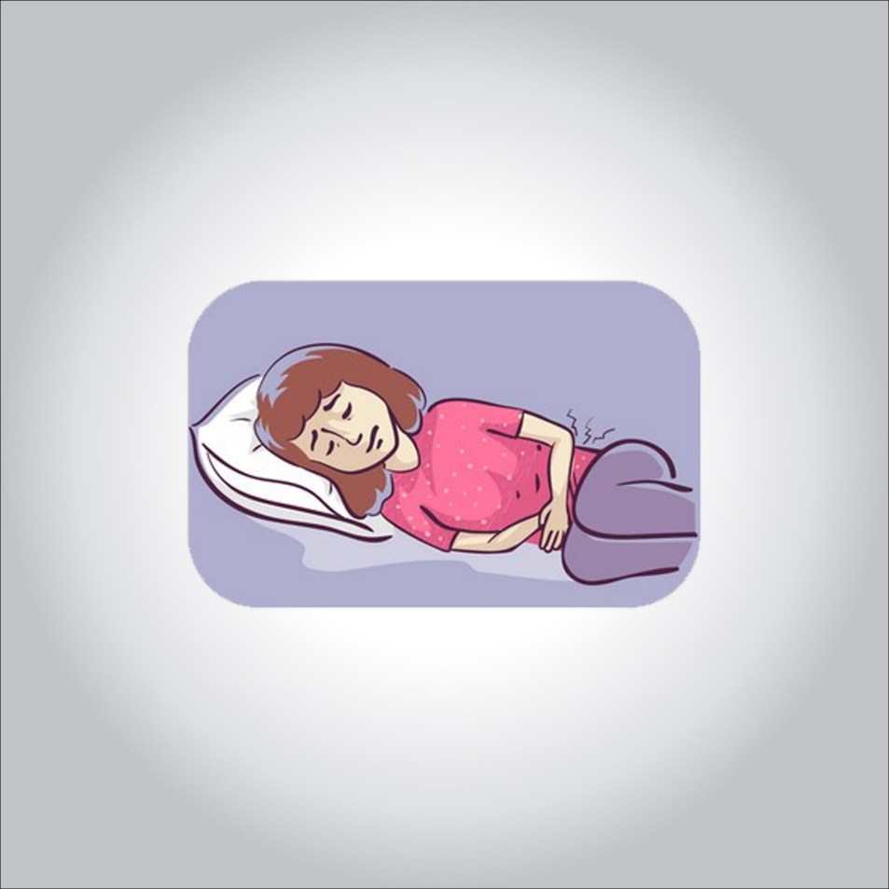

**Menstrual cramps (dysmenorrhea) are throbbing or cramping pains in the lower abdomen. Many women have menstrual cramps just before and during their menstrual periods.**

**For some women, the discomfort is merely annoying. For others, menstrual cramps can be severe enough to interfere with everyday activities for a few days every month.**

**Conditions such as endometriosis or uterine fibroids can cause menstrual cramps. Treating the cause is key to reducing the pain. Menstrual cramps that aren’t caused by another condition tend to lessen with age and often improve after giving birth.**

**Symptoms**

**Symptoms of menstrual cramps include:**

* **Throbbing or cramping pain in your lower abdomen that can be intense**
* **Pain that starts 1 to 3 days before your period, peaks 24 hours after the onset of your period and subsides in 2 to 3 days**
* **Dull, continuous ache**
* **Pain that radiates to your lower back and thighs**

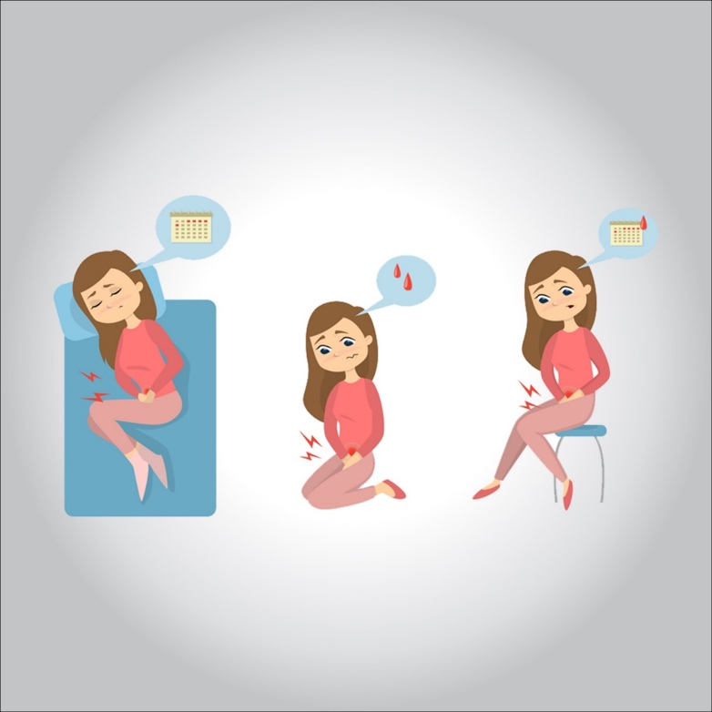

**Some women also have:**

* **Nausea**
* **Loose stools**
* **Headache**
* **Dizziness**

**When to see a doctor**

**If menstrual cramps disrupt your life every month, if your symptoms progressively worsen or if you just started having severe menstrual cramps after age 25, see your doctor.**

**Causes**

**During your menstrual period, your uterus contracts to help expel its lining. Hormonelike substances (prostaglandins) involved in pain and inflammation trigger the uterine muscle contractions. Higher levels of prostaglandins are associated with more-severe menstrual cramps.**

**Menstrual cramps can be caused by:**

* **Endometriosis. The tissue that lines your uterus becomes implanted outside your uterus, most commonly on your fallopian tubes, ovaries or the tissue lining your pelvis.**
* **Uterine fibroids. These noncancerous growths in the wall of the uterus can cause pain.**
* **Adenomyosis. The tissue that lines your uterus begins to grow into the muscular walls of the uterus.**
* **Pelvic inflammatory disease. This infection of the female reproductive organs is usually caused by sexually transmitted bacteria.**
* **Cervical stenosis. In some women, the opening of the cervix is small enough to impede menstrual flow, causing a painful increase of pressure within the uterus.**

**Risk factors**

**You might be at risk of menstrual cramps if:**

* **You’re younger than age 30**
* **You started puberty early, at age 11 or younger**
* **You bleed heavily during periods (menorrhagia)**
* **You have irregular menstrual bleeding (metrorrhagia)**
* **You have a family history of menstrual cramps (dysmenorrhea)**
* **You smoke**

**Complications**

**Menstrual cramps don’t cause other medical complications, but they can interfere with school, work and social activities.**

**Certain conditions associated with menstrual cramps can have complications, though. For example, endometriosis can cause fertility problems. Pelvic inflammatory disease can scar your fallopian tubes, increasing the risk of a fertilized egg implanting outside of your uterus (ectopic pregnancy).**

**Diagnosis**

**Your doctor will review your medical history and perform a physical exam, including a pelvic exam. During the pelvic exam, your doctor will check for abnormalities in your reproductive organs and look for signs of infection.**

**If your doctor suspects that a disorder is causing your menstrual cramps, he or she may recommend other tests, such as:**

* **Ultrasound. This test uses sound waves to create an image of your uterus, cervix, fallopian tubes and ovaries.**
* **Other imaging tests. A CT scan or MRI scan provides more detail than an ultrasound and can help your doctor diagnose underlying conditions. CT combines X-ray images taken from many angles to produce cross-sectional images of bones, organs and other soft tissues inside your body.**

**MRI uses radio waves and a powerful magnetic field to produce detailed images of internal structures. Both tests are noninvasive and painless.**

* **Laparoscopy. Although not usually necessary to diagnosis menstrual cramps, laparoscopy can help detect an underlying condition, such as endometriosis, adhesions, fibroids, ovarian cysts and ectopic pregnancy. During this outpatient surgery, your doctor views your abdominal cavity and reproductive organs by making tiny incisions in your abdomen and inserting a fiber-optic tube with a small camera lens.**

**Treatment**

**To ease your menstrual cramps, your doctor might recommend:**

* **Pain relievers. Over-the-counter pain relievers, such as ibuprofen (Advil, Motrin IB, others) or naproxen sodium (Aleve), at regular doses starting the day before you expect your period to begin can help control the pain of cramps. Prescription nonsteroidal anti-inflammatory drugs also are available.**

**Start taking the pain reliever at the beginning of your period, or as soon as you feel symptoms, and continue taking the medicine as directed for two to three days, or until your symptoms are gone.**

* **Hormonal birth control. Oral birth control pills contain hormones that prevent ovulation and reduce the severity of menstrual cramps. These hormones can also be delivered in several other forms: an injection, a skin patch, an implant placed under the skin of your arm, a flexible ring that you insert into your vagina, or an intrauterine device (IUD).**
* **Surgery. If your menstrual cramps are caused by a disorder such as endometriosis or fibroids, surgery to correct the problem might help your symptoms. Surgical removal of the uterus also might be an option if other approaches fail to ease your symptoms and if you’re not planning to have children.**

**Lifestyle and home remedies**

**Besides getting enough sleep and rest, things you might want to try include:**

* **Exercise regularly. Physical activity, including sex, helps ease menstrual cramps for some women.**
* **Use heat. Soaking in a hot bath or using a heating pad, hot water bottle or heat patch on your lower abdomen might ease menstrual cramps.**
* **Try dietary supplements. A number of studies have indicated that vitamin E, omega-3 fatty acids, vitamin B-1 (thiamin), vitamin B-6 and magnesium supplements might reduce menstrual cramps.**
* **Reduce stress. Psychological stress might increase your risk of menstrual cramps and their severity.**Bottom of Form